360° marketing & communications agency

The IMC brain for brands that scale.
Hilvarr builds the strategy, the systems, and the audience for brands moving into new markets across Africa and beyond. Every case study below is proof of work and what we can do for you.
40+
Brands built with
8
Countries
3
Continents

How we work
The Hilvarr Method. One system, applied to every brand, every market.
01

Decode
Read the market, the audience, and the business goal before writing a single word of strategy.
02

Design
Build the brand architecture, messaging, and channel plan around what the business actually needs to hit.
03

Deploy
Execute across every touchpoint, content, paid, PR, community, with the discipline of an in-house team.
04

Deepen
Turn one campaign into a system. Retarget, retain, and compound what worked.

Selected work

Blanet | Head of Communications & Marketing | 
- Authored the Q2–Q3 2026 Marketing & Communications Strategy (V2.0), covering brand awareness, demand generation, and market entry across May–October 2026
- Developed the Marketing & Communications Playbook V1.1, a full operational manual covering content production, approval frameworks, channel strategy, campaign management, testing, and crisis protocols
- Built the Marketing & Communications Department SOP (7 parts, 24 sections), establishing workflows for content creation, social media, partnerships, PR, webinar production, and influencer engagement
- Produced internal and external communications materials across formats including digital content, brochures, flyers, pitch decks, partnership proposals, government correspondence, brand memos, product demo scripts, social media copy, newsletter frameworks, press release templates,webinar briefs, exhibition materials.
- Managed a cross-functional stakeholder map spanning Nigerian parents, school proprietors, investors, telco partners, media, government regulators, NGOs, distribution partners, and church and community networks, with tailored engagement strategies and materials produced for each audience segment
- Led and managed the communications and marketing department with direct responsibility for task delegation, performance oversight, content quality control, and day-to-day operational direction; reported directly to the COO with biweekly touchpoints with the Founder & CIO
UNDER 40 CEOs Funnel & Conversion Manager | 
- Led the Q2 2026 membership acquisition campaign targeting 5,000 founding members across Nigeria, Ghana, South Africa, and Rwanda with a $1M+ revenue goal by Q2 end.
- Designed and deployed a 3-funnel conversion architecture operating simultaneously across all four markets.
- Engineered 5 parallel acquisition channels collectively targeting 5,000 members across four markets including LinkedIn InMail, Influencer Partnerships, Affiliate Programmes, Paid advertising, an organic content engine across campaign channels.
- Oversaw full-funnel KPI governance across all three funnels with weekly performance reports and real-time escalation protocols for critical issues.
- Coordinated a cross-functional team of 30+ including a CRM Manager, Performance Marketing lead, Creative team, Community Manager, and 26 sales closers across four markets while overseeing GoHighLevel pipelines, PostHog, Paid ad spend, Funnel copy, Member onboarding, and weekly close rate compliance reviews.
- Led A/B testing across all three funnel pages with performance compounding week-on-week toward the $1M+ campaign revenue target.
SellWela | Marketing Strategist 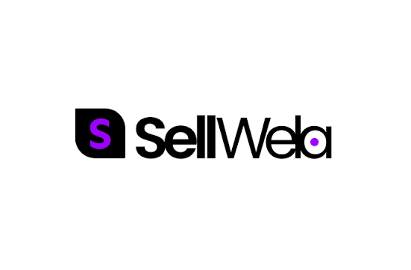
- Developing a comprehensive go-to-market strategy covering market segmentation, ideal customer profiling, product positioning, and channel sequencing across three core user segments.
- Architecting a product adoption lifecycle marketing framework spanning awareness, acquisition, activation, retention, and referral stages.
- Building a multi-channel demand generation engine across organic social, SEO, content marketing, email, and community-led growth engineered to drive app downloads, merchant onboarding, and early adopter acquisition at launch.
- Leading brand narrative and website copy development to articulate clear product-market fit and communicate Sellwela's value proposition compellingly across all user segments and digital touchpoints.
- Developing onboarding communications and activation sequences to reduce time-to-value for new merchants, improve feature adoption rates, and minimise early churn during the critical post-signup window.
- Building a referral and word-of-mouth growth strategy leveraging Sellwela's existing 50+ merchant base as brand advocates to drive organic product discovery and peer-to-peer acquisition within Nigerian SME communities.
Ropeways Transit Rwanda Limited | PR & Marketing Strategist 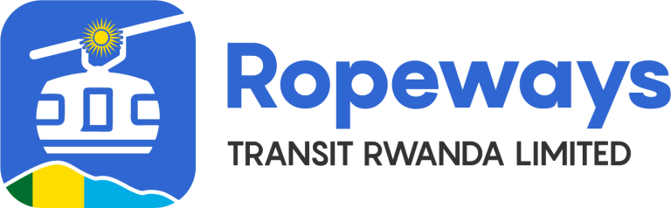
Engaged to build the entire communications, PR, and marketing infrastructure for Ropeways Transit Rwanda Limited developing East Africa's first urban cable car system in Kigali, backed by the African Development Bank and Doppelmayr from the ground up ahead of official public launch.
- Developing the company's full Brand Bible and strategic communications framework covering visual identity, messaging architecture, voice and tone guidelines, and channel-specific application templates.
- Building a tiered PR media relations database of verified contacts spanning Rwanda and East Africa outlets, continental media, international industry publications, and digital influencers, alongside a full media kit covering pitch deck, press release templates, founder biography, infographics, and FAQ document.
- Designing a three-tier stakeholder communications protocol ensuring government partners, investors, and board members are always notified ahead of any public-facing media release.
- Developing the founder's complete personal brand strategy, media training programme, and media kit ensuring full media readiness ahead of the official launch
- Architecting full digital presence across owned and paid channels including SEM, Google Ads, GA4, Search Console, Wikipedia business profile, and a content marketing engine publishing SEO-optimised blogs monthly.
- Designing a four-segment email marketing infrastructure with templates spanning stakeholder newsletters, press releases, event invitations, and founder updates.
- Leading strategic planning for Ropeways Transit's Platinum Sponsorship activation at Rwanda Homecoming 2026 under the campaign concept "Coming Home to New Heights" covering booth activation, founder keynote, VIP investor and government site visit logistics, full media programme, documentary pre-production, and an investor pipeline strategy targeting high-potential diaspora attendees.
Performance Marketer, Imogen Grace Socials UK (a partnership between our agency and Imogen grace social agency to manage performance marketing for their clients)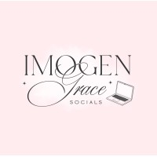
- Planned and executed a full Meta paid advertising campaign for Q Acoustics, a speaker brand, across Facebook and Instagram, managing strategy, audience targeting, budget allocation, creative direction, and performance optimisation across a two-product campaign for the M20 and M40 speaker lines during the peak November–December shopping period.
- Deployed £520.30 in total ad spend, reaching 36,937 unique users and generating 90,624 impressions at a CPM of £5.74, significantly below the industry benchmark of £10, indicating strong audience-to-product fit and efficient Meta delivery.
- Achieved a 3.66% overall CTR and 1.97% link CTR, surpassing the 1% industry benchmark, driving 1,785 high-intent website visitors at a cost per click of £0.29, against an industry average of £0.80–£1.50, representing a 3–5x efficiency gain on traffic acquisition cost.
- Generated 86,277 video views and 29,885 engagements, nearly 1 in 3 impressions resulting in an interaction, validating creative quality, product appeal, and audience relevance across both placements.
- Conducted mid-campaign budget reallocation based on real-time performance data, shifting spend toward the M20 creative after identifying it delivered 60% more clicks at 26% lower cost per click (£0.26) compared to the M40 (£0.35), a data-driven decision that maximised return on remaining budget.
- 1,785 warm site visitors generated, a conservative 3–5% conversion rate at an average order value of £599 projects an estimated £32,000–£53,000 in demand generated from £520 in spend.
- Developed a full post-campaign strategic roadmap including retargeting architecture for 86,000+ warm video viewers and 1,785 site visitors, creative testing recommendations spanning UGC-style video, static imagery, and carousel formats, and a phased scaling plan tied to ROAS targets upon storefront activation.
Desa Foods | Content Marketing & Brand Relaunch
- Led the end-to-end content marketing strategy for Desa Foods' brand relaunch, architecting a full-funnel content system across Instagram, Facebook, LinkedIn, and X. Developed a diverse content mix, each piece mapped to a specific stage of the customer journey and aligned with the brand's revenue and audience growth targets.
- Designed and implemented a strategic content calendar with an optimised posting cadence built around platform algorithms, audience behaviour patterns, and peak engagement windows.
- Ensured brand consistency across all four channels while tailoring tone, format, and messaging to platform-specific audiences.
- The campaign delivered measurable commercial impact, amplifying brand visibility across targeted audience segments and directly contributing to Desa Foods hitting its Q3 revenue goals while establishing a stronger, more recognisable brand presence in the market.
The Memo | Integrated Event Marketing & Communications Manager 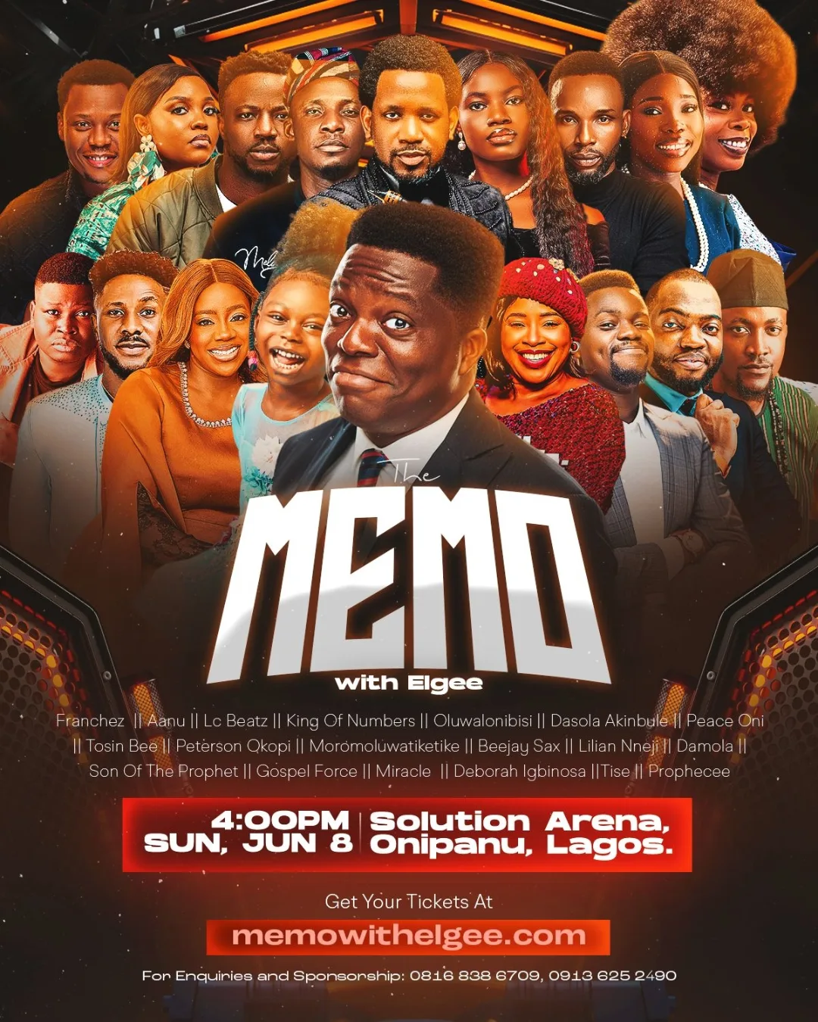
- Led the full integrated marketing and communications strategy for The Memo's event launch, overseeing a multi-channel campaign that spanned organic social media, email marketing, influencer management, mobile push notifications, and on-site content production.
- Developed and executed a conversion-focused content marketing strategy in collaboration with motion and graphic designers, generating 200,000+ organic social media impressions across the campaign lifecycle.
- Grew the brand's social media following by 33% over three months, spanning both pre- and post-event phases, through consistent community engagement, strategic content distribution, and active audience interaction including comment management and follower engagement.
- Coordinated a network of 6 influencers to execute pre-event awareness and conversion campaigns, managing creative briefs, posting schedules, and brand alignment across all influencer touchpoints.
- On event day, managed a team of 7 on-site content creators, directing real-time content capture and ensuring seamless live coverage across all platforms.
- Engineered a high-performing email marketing sequence that maintained a 52% open rate and 11% click-through rate, significantly above industry benchmarks, while also deploying mobile push notifications to drive last-mile conversions and attendance confirmation.
- The campaign's cumulative impact resulted in all 1,000 event seats selling out within weeks of launch, delivering a fully sold-out event driven almost entirely by organic and owned-channel marketing.
HerSpine Solutions, UK | Content Marketing & Social Media Strategy

- Built and executed a full-funnel marketing and communications strategy from the ground up for HerSpine Solutions, a platform serving women living with Spinal Cord Injuries, across five channels, Facebook, LinkedIn, Instagram, Twitter, and email, establishing the brand's entire digital presence from zero.
- Crafted thought-leadership posts to position HerSpine Solutions as an authoritative, trusted voice in the women's spinal health space, building credibility with both community members and potential partners.
- Built and managed a full newsletter sequence and authored 30+ blogs and newsletters engineered to educate, mobilise, and retain subscribers, growing a loyal, engaged readership from scratch.
- Scaled the newsletter to 500+ subscribers within just 3 weeks of launch, a direct result of a conversion-focused content and email strategy built for rapid audience acquisition.
- Deployed targeted inbound PR strategies to attract organic collaborations, leveraging thought-leadership content and community visibility to draw SCI organisations and advocates into the brand's orbit.
- Grew the brand's social media following to 1,000+ organic followers across all platforms within 5 months of launch, driven entirely by strategic content and community engagement.
- Onboarded 100+ community members across 5 countries, transforming HerSpine Solutions from a local initiative into a growing international community for women living with spinal cord injuries.
- Secured 3 SCI company partnerships and 5 advocate collaborations, establishing HerSpine Solutions as a recognised and respected player in the global SCI advocacy space.
Hammer Pay Africa, US + Liberia | Marketing, Communications, & PR Executive

- Leading the end-to-end marketing and communications strategy for Hammer Pay Africa's multi-market fintech product launch into the Liberian market, owning everything from brand architecture and messaging frameworks to digital channel buildout and go-to-market execution.
- Developing a comprehensive brand and product marketing suite including a full branding kit, CEO LinkedIn personal brand strategy, platform-specific content frameworks across Instagram, Facebook, X, and LinkedIn, and SEO-ready digital assets designed to drive organic product discovery and user acquisition.
- Engineering high-converting merchant acquisition pitch decks to support the sales and partnerships pipeline, translating complex fintech product value propositions into compelling, market-ready narratives for merchant and investor audiences.
- Building and deploying a full email marketing system to support product onboarding communications and user retention sequences.
- Overseeing end-to-end website development alongside a two-person front-end development team, and contributed directly to app development and user testing, ensuring brand consistency across every product touchpoint from web to mobile.
The Kingdom Emphasis Community | Content Marketing & Community Growth
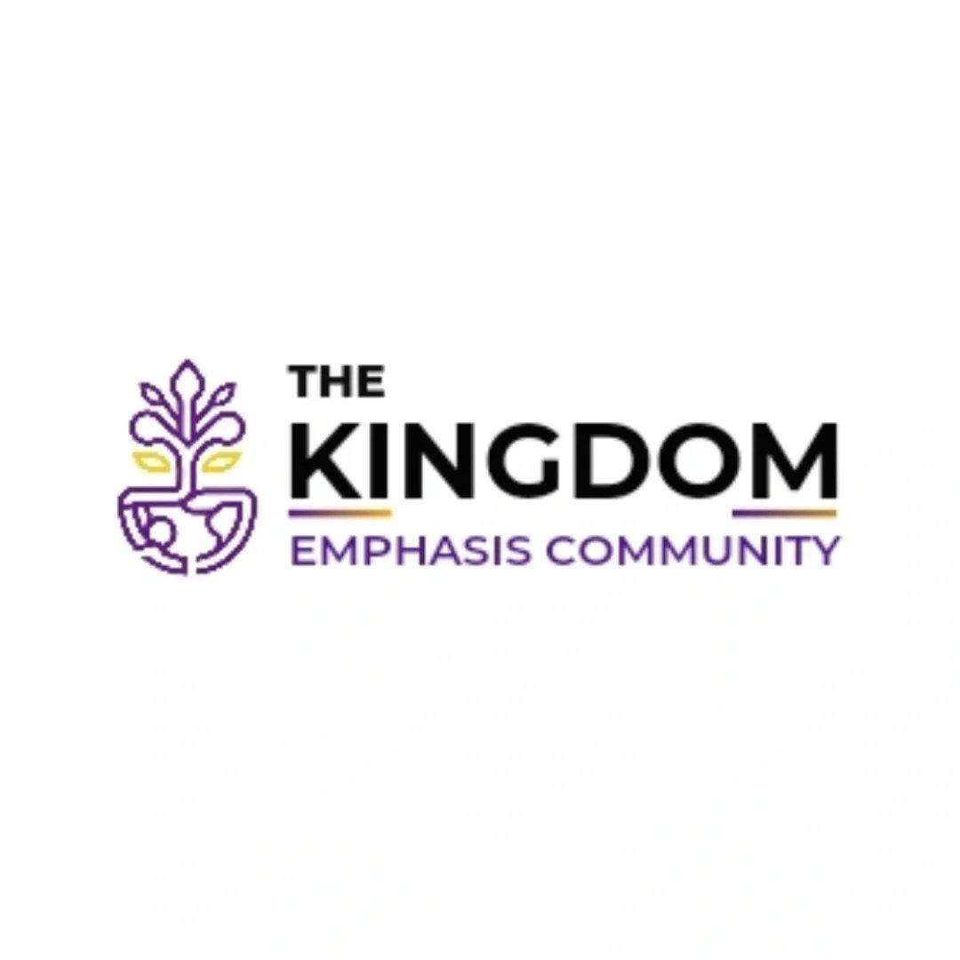
- Developed and executed a full content marketing strategy for The Kingdom Emphasis Community, a faith-based brand, transforming raw podcast audio into a high-performing, multi-format content ecosystem designed to grow community engagement and expand digital reach.
- Transcribed and repurposed 10+ podcast episodes into platform-optimised content formats, ensuring every episode lived beyond its original audio format and reached audiences who consume content differently across platforms.
- Built out a diverse content mix of carousels, reels, flyers, and captions, each piece engineered to extend the life and reach of the brand's core message while remaining deeply aligned with its spiritual mission and audience values.
- Designed and implemented a strategic content calendar to bring structure and intentionality to the brand's content distribution, eliminating inconsistency and ensuring the community received regular, meaningful touchpoints across all active social channels.
Stellar Writes | SEO & Website Performance Optimisation 
- Audited and optimised the CMS backend for Stellar Writes, identifying technical gaps and implementing a full on-page and off-page SEO strategy to improve website performance, strengthen domain authority, and increase page rankings across Google SERPs.
- Conducted comprehensive keyword research and integrated targeted search terms across site architecture, metadata, headers, and content, ensuring every page was structured to be discovered by the right audience at the right time.
- Executed off-page SEO strategies including link building and external visibility efforts to strengthen the site's authority signals and improve its competitive positioning within search engine rankings, laying a strong SEO foundation for Stellar Writes to grow its digital presence sustainably.

Marketing and Branding Assistant at Xcentrique Media 
- Partnering with other team members on internal marketing operations, LMS development, client acquisition, and the company's flagship CSR initiative, Marketing Girls Corner (MGC).
- Contributed to the build-out of Xcentrique Media's Learning Management System (LMS), developing structured learning curricula for both corporate and personal brand clients.
- Designed and organised course topics spanning integrated marketing communications, social media marketing, email marketing, and LinkedIn personal branding, translating complex marketing disciplines into accessible, structured learning experiences for clients at varying levels of expertise.
Marketing Girls Corner (MGC) | Programs Assistant 
- Led the operations, programming, and community growth strategy for Marketing Girls Corner, Xcentrique Media's CSR initiative dedicated to helping young women build careers and thrive in the marketing industry.
- Developed and implemented structured learning programs designed to equip young women with practical, industry-relevant marketing skills, bridging the gap between academic knowledge and real-world marketing practice.
- Managed and led a team of 5 volunteers, overseeing content workflow, task delegation, community engagement, and day-to-day operations, ensuring the initiative ran with the structure and intentionality of a fully functioning marketing organisation.
- Grew the MGC community by 50% within 3 months through strategic content programming, value-led initiatives, and targeted partnership development, turning a nascent community into a thriving, engaged network of young women in marketing.
- Launched 2 marketing bootcamps and 3 webinars within 4 months, creating structured, accessible learning opportunities for young women entering the digital marketing space and building MGC's reputation as a go-to platform for early-career marketers.
- Created and managed social media content across MGC's platforms, driving an additional 20% growth in page visibility and engagement, expanding the community's reach and attracting new members consistently.
- Conducted a LinkedIn optimisation audit for 30 members in a single webinar session and delivered 1-on-1 CV reviews for 5 members, providing personalised, career-accelerating support that directly improved their employability and professional positioning.
- Actively sourced and shared job opportunities within the community, supporting member placements and contributing to a 35% increase in job acquisition rate among MGC members.
- Developed multiple high-impact pitch decks to support client acquisition efforts, initiating conversations with major prospects including Meta, TikTok, MTN, and Providus Bank, positioning Xcentrique Media as a credible, forward-thinking marketing and personal branding partner.
Content & Campaign Lead at The Heart Therapy Initiative 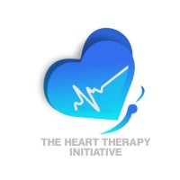
- Led content strategy and campaign execution for The Heart Therapy Initiative, a mental health platform, owning the brand's editorial direction, community engagement, and campaign activations across digital channels.
- Developed and managed strategic content calendars for Instagram, establishing a consistent brand messaging framework and optimised posting cadence that ensured the brand showed up reliably and meaningfully for its audience.
- Wrote and produced a diverse range of content formats including video scripts, Medium blogs, and platform-optimised social media posts, each crafted to educate and engage audiences around mental health topics while driving measurable growth in reach and engagement.
- Led mental health awareness activation campaigns designed to drive community participation and deepen brand visibility, translating sensitive, high-stakes subject matter into compelling, accessible communications that resonated with the platform's audience.
- Collaborated closely with graphic designers to develop visually compelling content aligned with the brand's aesthetic identity, ensuring every piece of content was both strategically sound and visually consistent.
- Managed and guided internal teams through content production and campaign execution cycles, maintaining smooth operational workflows and ensuring consistent delivery across all active initiatives.

